MATH ASSIGMENT
Name:
University:

QUESTION 1
Simply the following trigonometric equation and show your working
$$\frac{1}{1+\sin{θ}}+\frac{1}{1-\sin{θ}}$$
From the trigonometric charts
$$\frac{\left\lfloor \left(1-sinθ\right)+\left(1+sinθ\right)\right\rfloor }{\left(1-\sin^{2}θ\right)}$$
Therefore
=$\frac{2}{\cos^{2}θ}$
Hence
$$=2×\sec^{2}θ$$

Question 2
2) In , is a right angle. Find the remaining sides and angles. Round your answers to the nearest tenth. Show your work.
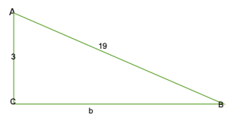
From Pythagoras theorem
$a^{2}$+$b^{2}=c^{2}$
$$b^{2}={19}^{2}-3^{2}$$
$$b^{2}=361-9$$
$b=\sqrt{352}$ =18.76
SOHCAHTOA
Sin A=$\frac{3}{19}$ Sin B=$\frac{18.76}{19}$ $<A=9.1$ $<B=80.88$
3) Please show your work to find the mean and standard deviation of the data. Round to the nearest tenth.
20, 16, 18, 14, 9, 20, 16

Mean=$\frac{1}{n}\sum_{n=0}^{n}{x}$ =20+16+18+14+9+20+16=113 n=7 mean equal $\frac{113}{7}$ =16.14
Standard=$\sqrt{\frac{\left|X-x̄\right|}{7}}$ = (20 – 16.1)² + (16 – 16.1)² + (18-6.1)²+(14-16.1)²+(9-16.1)² +(20-16.1)² +(16-16.1)² ⁼$\sqrt{\frac{622}{7}}$ $=3.8483$
⁴⁾ What are the points of discontinuity? Are they all removable? Please show your work
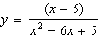
=$\frac{\left(x-5\right)}{\left(x-5\right)\left(x-1\right)}$ hence$\frac{1}{\left(x-1\right)}$ the function is discontinuous at x=1
The discontinuity can be removed when x=5
5) A sound wave is modeled with the equation 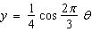.
a. Find the period. Explain your method.
The formula for finding the period y= a cos (k×Ɵ) is given by $\frac{2π}{k}$
Radians=$\frac{radians}{360}$ therefore $\frac{2π}{\frac{2}{3}π}$ =$\frac{2π3}{2π}$ =3 radius
b. Find the amplitude. Explain your method.
y=a cos(k*$θ$)
amplitude is |a|
amplitude is $\frac{1}{4}$
c. What is the equation of the midline? What does it represent?
Since no function is being subtracted or added the middle line in this case is the x-axis
6) . Paula spots a glider located at an angle of elevation of 42°. The distance between the glider and Paula is 3280 feet. To the nearest foot, what is the height of the glider h from the ground?
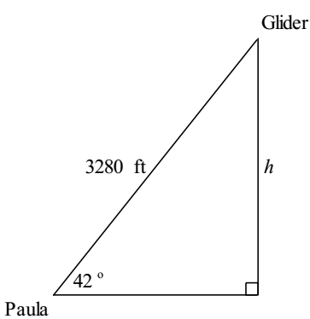
The distance between Paulo and glider =3280ft
SOHCAHTOA
Sin=$\frac{opposite}{hypomuse}$
Sin 42⁰= opp/3280
0.6691*3280= 2195ft
h=2195ft
7) . What is the product in simplest form? State any restrictions on the variable. Please show your work.
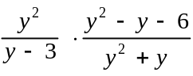
$\frac{y^{2}\left\{y^{2}-y-6\right\}}{y\left\{y^{2}+y\right\}-3\left\{y^{2}+y\right\}}$ $y^{3}+y^{2}-3y^{2}-3y$

=$\frac{y^{4}-y^{3}-6y^{2}}{y^{2}-2y^{2}-3y}$ hence the simplest form =$\frac{y^{2}+2y}{y+1}$
8) Verify the identity. Justify each step

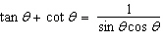
Tan=$\frac{\sin{θ}}{\cos{θ}}$, Cot $θ=\frac{\cos{θ}}{\sin{θ}}$
$\tan{θ+\cot{θ=\frac{\sin{θ}}{\cos{θ}}+}}\frac{\cos{θ}}{\sin{θ}}$= $\frac{\sin^{2}θ+\cos^{2}θ}{\cos{θ\sin{θ}}}$
$$\sin^{2}θ+\cos^{2}θ=1$$
Therefore $\frac{1}{\cos{θ\sin{θ}}}$
9) Is there any bias in the survey question? Explain.

What do think would help students pay more attention in class?
Yes, because there is an assumption that the students are not paying attention in class and that they need help

10. Find the values of the 30th and 90th percentiles of the data. Please show your work.
129, 113, 200, 100, 105, 132, 100, 176, 146, 152
The percentile position=$\left\{p/{100}\right\}×10+0.5$
=$\left\{{30}/{100}\right\}×10+0.5$ ==$>\frac{300}{100}+0.5$ =3.5
=$\left\{{90}/{100}\right\}×10+0.5$ ==$>\frac{900}{100}+0.5$ =9.5
The numbers from smallest to largest
100,100,105,113,129,132,146,152,176,200
9.5$≅10$ therefore 90 percentile 200
3.5$≅4$therefore 30 percentile 113
11). What is the quotient in simplified form? State any restrictions on the variable
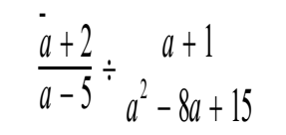
$\frac{a+2}{a-5}$÷$\frac{a+1}{a^{2}-8a+15}$ ==$>$ $\frac{a+2}{a-5}/\frac{a+1}{(a-3)(a-5)}$
$$\frac{a+2}{a-5}/\frac{(a-3)(a-5)}{a+1}$$
$\frac{a+2}{{(a-3)}/{(a-1)}}$ restrictions: -1, 3, 5
12) . Vance is designing a garden in the shape of an isosceles triangle. The base of the garden is 36 feet long. The function models the height of the triangular garden.
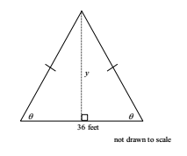
a). What is the height of the triangle when
y=18tan 45⁰ ==$>$18 ft
b. What is the height of the triangle when
y=18 tan 55⁰ ==$>$ 25.7ft
c) Vance is considering using either or for his garden. Compare the areas of the two possible gardens
a1=1/2ab 0.5*36*18=324ft² a₂=1/2bh 0.5*36*25.7=462.6ft²
¹³⁾ . Verify the identity. Justify each step.
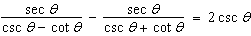
=sec(θ)[1/(csc(θ) – cot(θ))-1/(csc(θ)+ cot(θ))]
= sec(θ)[csc(θ)+ cot(θ)-csc(θ)+cot(θ)]/[(csc(θ))^2-(cot(θ))^2]
= sec(θ)[2cot(θ)]/1
= sec(θ)*2 cos(θ)/sin(θ)
= 2(sec(θ)*cos(θ)*csc(θ)
= 2csc(θ)
sec(θ)/csc(θ)-cot(θ) – sec(θ)/csc(θ) + cot(θ) = 2csc(θ) hence proven
14. Compare the graphs of the inverse variations. Please provide at least 3 comparisons

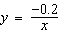 and 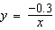
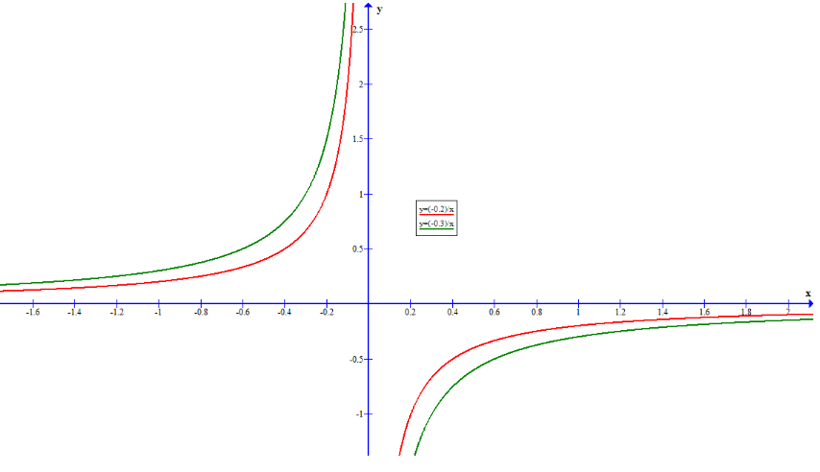
y→0 as x→±∞ for both equations
y→+∞ as x→0− and y→−∞ as x→+0 for both equations
y=$-\frac{0.2}{x}$ is closer to the origin than y= $\frac{-0.03}{x}$ in the sense that a straight line drawn from the origin will intersect y=$\frac{-0.2}{x}$ before intersecting y=$-\frac{0.3}{x}$.

15. Use a graphing calculator to solve the equation in the interval from . Round to the nearest hundredth.
-3cost = 1
cos(t) = -1/3
t=$\cos^{-1}\frac{ - 1 }{3}$ =109.43 degrees or
250.53 degrees
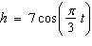
16) The equation models the height h in centimeters after t seconds of a weight attached to the end of a spring that has been stretched and then released.

- Solve the equation for t.
h=7cos[(π/3)t]
h/7=cos[(π/3)t]
cos⁻¹(h/7)=(π)t/3
t=$\frac{3 cos-1 (h/7)}{π}$
- Find the times at which the weight is first at a height of 1 cm, of 3 cm, and of 5 cm above the rest position. Round your answers to the nearest hundredth.
h=1cm
+(1) = [3*cos^-1(1/7)]/π = [3*81.79]/π = 78.10 seconds
+(3) = [3*cos^-1(3/7)]/π= 61.71seconds
+(5) = [3*cos^-1(5/7)]/π = 42.42 seconds
- Find the times at which the weight is at a height of 1 cm, of 3 cm, and of 5 cm below the rest position for the second time. Round your answers to the nearest hundredth.

t(1) = 265.67 sec
t (3) = 282.06 sec
t (5) = 301.36 sec
17) Consider the graph of the cosine function shown below.
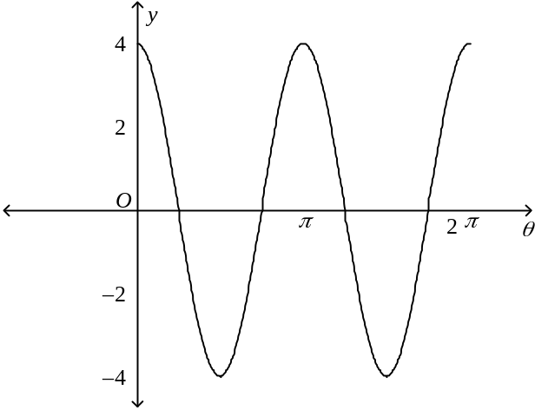
a. Find the period and amplitude of the cosine function.
period is 2π/2=π
amplitude =4
b. At what values of for do the maximum value(s), minimum values(s), and zeros occur?
B. max value x=0+2π*k
min value x=π/4+2π*k
Zeros x=π/4+2π*k and x=3/4*π+2π*k
18) Use the graph of the sine function shown below.
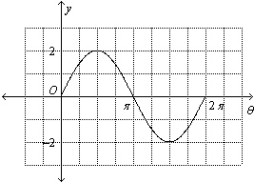
- How many cycles occur in the graph? 2 cycles
- Find the period of the graph. period =2π
- Find the amplitude of the graph=2
19) . Verify the Pythagorean Identity
cot(θ)=cos(θ)/sin(θ)
csc(θ)=1/sin(θ)
20) Howard is flying a kite and wants to find its angle of elevation. The string on the kite is 32 meters long and the kite is level with the top of a building that he knows is 28 meters high.
To the nearest tenth of a degree, find the angle of elevation.
sin(θ)=28/32
a=sin⁻¹(28/31)
a=61⁰

